**PRO201 Project Plan**

# Overview Structure:

**\*Make use of Cookie in replacement of DB (temporary)**

## HTML/UI

### Main

* **User Independent:**

+ *Home (Home.html)*

+ *Login (Login.html)*

[Login] Form

* **User Dependent:**

+ *Customer*

. Register (Register.html)

[Register] Form

. Cart (Cart.html)

[Check Out] Form

. Edit Info (Edit.html)

[Edit Personal Info] Form

. Product Review

[Review Submit] Form

+ *Manager*

. Full control of database (System.html)

[Add/Delete/Edit Staff’s Info.] Form

[Add/Delete/Edit Order’s Info] Form

[Add/Delete/Edit Customer’s Info] Form

[Add/Delete/Edit Stock’s Info] Form

+ *Staff*

. Partial control of database (Manage.html)

[Order Confirmation] Form

. [Customer Response] Form

**\*Each has dedicated JS + CSS**

### Component

* **Header**
* **Side Bars**
* **Footer**

## Main CSS

# Constraints & Requirements

* Browser support CSS3, HTML5, JS, recommends Google Chrome
* Cookies containing user’s login and cart expires after 1 day or on browser closing
* Maximum quantity per. Product for order shall be 20

# Use Cases

## Login

* 1. User accesses Login page
  2. Fills in username/password
  3. click [Login]
  4. User gets redirected to Home page

## Customer

### Register

* + 1. Customer goes to Register page, fills in Info. With valid inputs
    2. Click [Register]
    3. Server sends confirmation email
    4. Customer verifies registration via email, thus successes signing up

### Add to Cart

* + 1. Customer clicks on [Add] under a product’s summary or in product’s detail page
    2. Product is registered into customer’s cart and cookie

### View Cart

* + 1. Customer goes to Cart page
    2. List of added products in cookie will be loaded and showed in Cart page

### Check Out

* + 1. Customer clicks on [Check Out] in Cart page
    2. Customer verifies proceed via window prompt
    3. Customer logs into their account to proceed transaction
    4. Server sends email to confirm purchase’s authenticity

### Edit Personal Info

* + 1. Customer logs in
    2. Customer proceed to Account Detail page
    3. Customer clicks [Edit] then fills in new info
    4. Customer finishes by clicking on [Save]
    5. Server sends email to confirm account’s detail changes

## Staff

### View Orders

* + 1. Staff logs into their given account
    2. Staff will be given list of pending orders in Manage page

### Assign Orders

* + 1. Staff shall be able to verifies and assign eligible orders by clicking [Confirm] next to each order

### Request Restock

* + 1. Staff shall be able to aggregate ordered products by clicking [Total]
    2. Fills in needed quantity of product, then click [Request]

## Manager

* Manager logs into their account
* Proceed to System page

+ Clicks on [Delete] next to an entry to delete

+ Fills in entry’s info in the last row then clicks on [Add] to add a new entry

+ Clicks on [Edit] next to an entry, edits generated text fields in the same row, then clicks [Save] to edit an entry

### View/Add/Delete/Edit Orders

### View/Add/Delete/Edit Customers

### View/Add/Delete/Edit Staff

### View/Add/Delete/Edit Stocks

# Phrase 1:

* Draft Forms + UIs

# Phrase 2:

* Draft Styles + Scripts

# Phrase 3:

* Complete Forms + UIs

# Phrase 4:

* Complete Scripts, Fix Bugs, Business Logics, etc.

# Appendix

## Home (Home.html) (Prototype)

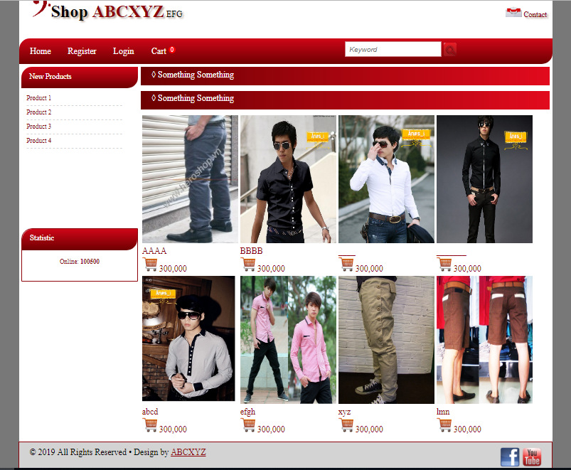

**\*Header, sidebar, footer shall be static**

## Login (Login.html) (Prototype)

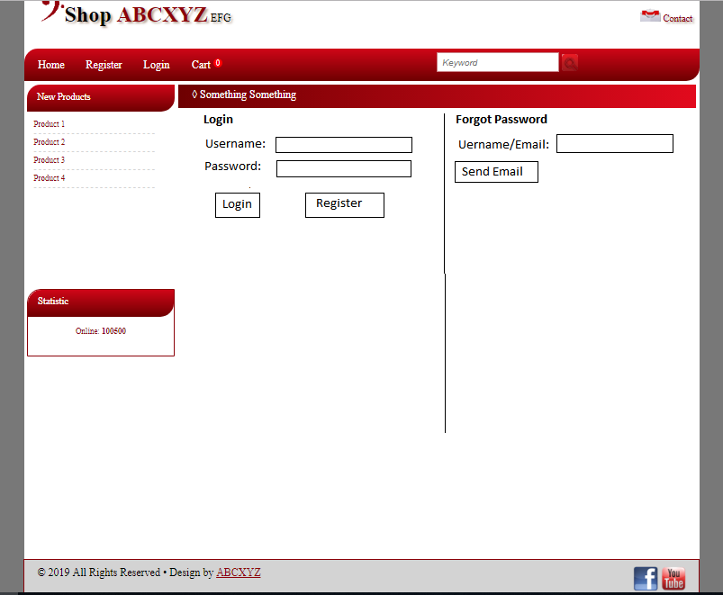

## Register (Register.html)

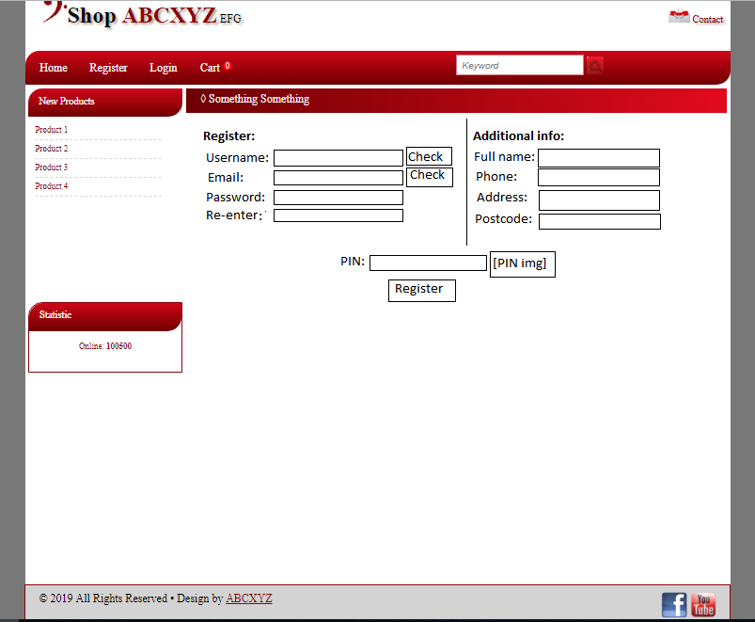

## Cart (Cart.html)

## Manage (Manage.html)